Problem#3 Option#1
1.Fibonacci sequence.
import java.util.Scanner;

public class Fibonacci
{
public static void main(String args[])
{
long[] ar = new long[1000000];
ar[0]=0;
ar[1]=1;
int n;
Scanner scan=new Scanner(System.in);
System.out.println("Enter a value of n:");
n=scan.nextInt();
for(int i=2;i<n;i++)
ar[i]=ar[i-1]+ar[i-2];
for(int i=0;i<n;i++)
System.out.print(ar[i]+" ");

}

}
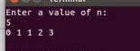

2.EvenOdd
import java.util.Scanner;

public class EvenOdd
{
public static void main(String args[])
{
Scanner scan=new Scanner(System.in);
int a;
a=scan.nextInt();
if(a%2==0)
System.out.println("True");
else
System.out.println("False");
}

}
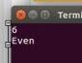

Problem#3 Option#2
public class Numbers {
private int num;
public Numbers(int num){
this.num=num;
}
public void showFibonacci(){
long[] ar = new long[1000000];
ar[0]=0;
ar[1]=1;
for(int i=2;i<num;i++)ar[i]=ar[i-1]+ar[i-2];
for(int i=0;i<num;i++)System.out.print(ar[i]+" ");
System.out.print("\n\n");
}
public void showPyramid(){
int n=num;
if(n>9) n=9;
int s=n;
for(int i=1;i<=n;i++){
for(int j=0;j<s-i;j++)System.out.print(" ");
for(int k=1;k<=i;k++)System.out.print(k);
for(int l=i-1;l>=1;l--)System.out.print(l);
System.out.print("\n");
}
System.out.print("\n\n");
}
public boolean checkNumber(){
if(num%2==0)return true;
elsereturn false;
}
public void setNum(int num){
this.num=num;
}
}

public class Number2 {
public static void main(String[] args) {
Numbers a=new Numbers(5);
a.showFibonacci();
a.showPyramid();
System.out.print(a.checkNumber());
a.setNum(85);
System.out.print("\n\n");
a.showFibonacci();
a.showPyramid();
System.out.print(a.checkNumber());
}
}
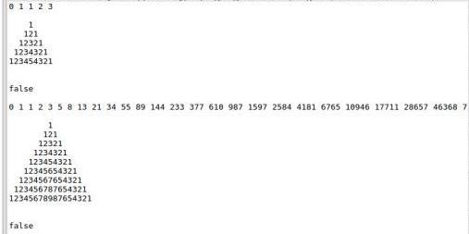

Problem#4
public class Problem4{
public static void main(String args[]){
String[][] a = new String[3][4];
int b=0;
for(int i=0;i<3;i++){
int d=0;
for(int j=0;j<4;j++){
a[i][j]=Integer.toString(b)+Integer.toString(d);
d++;
}
b++;
}
for(int i=0;i<3;i++)
{
System.out.print("|");
for(int j=0;j<4;j++)
{
System.out.print(a[i][j]);
if(j<4-1)
System.out.print(" ");
}
System.out.print("|");
System.out.println("");
}

}

}

